

**YEAR: 8**

**SUBJECT: SCIENCE**

**TEST: Matter**

**TIME: 50 mins**

**QUESTIONS: Part A: Multiple Choice Questions (10 marks)**

**Part B: Short Answer Questions (29 marks)**

**Part C: Extended Answer Question (5 marks)**

**TOTAL MARKS: 44 marks**

**DO NOT WRITE ON OR MARK THIS PAPER**

**Part A: Multiple Choice Questions (1 mark each)**

1. Which of the following is ***not*** a physical property of substances?
2. the density of a substance
3. the strength of a substance
4. the temperature at which a substance will boil
5. how a substance reacts when combined with another substance
6. According to the particle model:
7. all matter is made of atoms that have no mass and are too small to be seen with the naked eye.
8. some matter is made of atoms that have mass and are small, but can be seen with the naked eye.
9. all matter is made of atoms that have mass and are small, but can be seen with the naked eye.
10. all matter is made of atoms that have mass but are too small to be seen with the naked eye.

1. The diagram represents:
2. A compound
3. A mixture
4. An element
5. An atom
6. Melting point is the temperature at which a
7. liquid changes to a gas.
8. solid changes to a gas.
9. liquid changes to a solid.
10. solid changes to a liquid.
11. Describe the particles in a solid. The particles in a solid are
12. strongly attracted to each other so the solid has a definite shape.
13. strongly attracted to each other so the solid does not have a definite shape.
14. weakly attracted to each other so the solid has a definite shape.
15. weakly attracted to each other so the solid does not have a definite shape.
16. Elements are represented by chemical symbol. Symbols are written with:

a. All lower case letters

b. All capital letters

c. Always only one letter

d. at least and ONLY one capital letter

.

1. What is usually required for a change in the state of matter of a substance? A change in the
2. type of atoms.
3. number of atoms.
4. chemical potential energy of the atoms.
5. amount of heat energy.
6. As a solid object is heated, its particles:

a. vibrate less rapidly and cause it to contract.

b. vibrate more rapidly and cause it to expand.

c. attract each other more, causing contraction.

d. shrink in size so the gaps between them increase.

1. Four different substances were transferred from a test tube to a beaker. The table below shows changes of shape or volume which occurred.

|  |  |  |
| --- | --- | --- |
| **Substance** | **Did it change its shape when transferred?** | **Did it change its volume when transferred?** |
| A | YES | YES |
| B | YES | NO |
| C | NO | YES |
| D | NO | NO |

Which one of the substances do you think was solid?

1. A
2. B
3. C
4. D
5. Which of the following describe what is occurring to the particles during melting? The particles…
6. vibrate less rapidly and causes contraction of the volume.
7. vibrate more rapidly and causes expansion of the volume.
8. attract each other more, causing contraction of the volume.
9. expand in size.



**YEAR: 8**

**SUBJECT: SCIENCE**

**Name________________________________________________  
  
Class ____________**

**Part A: Multiple Choice Answers (1 mark each)**

Put a cross (X) through the correct answer.

|  |  |  |  |  |
| --- | --- | --- | --- | --- |
| **1** | a | b | c | d |
| **2** | a | b | c | d |
| **3** | a | b | c | d |
| **4** | a | b | c | d |
| **5** | a | b | c | d |
| **6** | a | b | c | d |
| **7** | a | b | c | d |
| **8** | a | b | c | d |
| **9** | a | b | c | d |
| **10** | a | b | c | d |

Part A: Part B: Part C:

Multiple Choice Short Answer Extended Answer TOTAL

/29

/44

/5

/10

/20

|  |  |
| --- | --- |
| **I CAN STATEMENTS** | **QUESTIONS** |
| **MUST**  Uses the particle model to briefly explain and predict the properties and behaviour of solids, liquids and gases. | 1, 3, 4, 5, 6, 7, 9, 11, 12, 13, 14, 15, 18, 19, 20 |
| **SHOULD**  Uses the particle model to explain and predict the properties and behaviour of solids, liquids and gases. | 2, 8, 13, 14, 17, 19, 20 |
| **COULD**  Uses the particle model to explain in detail and predict the properties and behaviour of solids, liquids and gases. | 10, 16, 20 |

**Part B: Short Answer Questions**

1. Draw the particles in a solid, liquid and a gas. (3 marks)

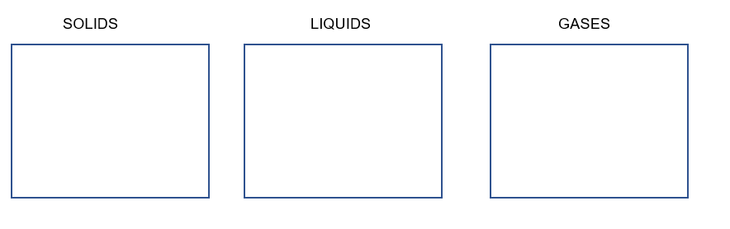

1. Identify the state of matter and the names of the processes occurring between each change of state using the word bank below. (4.5 marks)

WORD BANK:  
Liquid Evaporation Sublimation Freezing Melting

Solid Condensation Deposition Gas

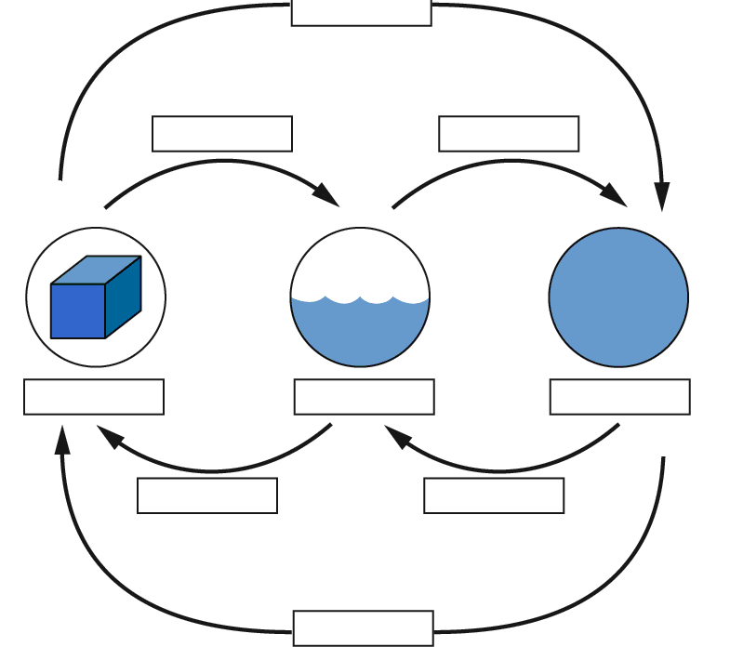

13. Which one of the states of matter is said to be compressible? Describe why this state can be compressed while the others cannot. (2.5 marks)

________________________________________________________________________________________________________________________________________________________________  
________________________________________________________________________________

14**.** **Define** chemical property. Write an **example** of a chemical property of a state of matter to support your answer. (2 marks)

________________________________________________________________________________________________________________________________________________________________  
________________________________________________________________________________________________________________________________________________________________

15. **Define** the following properties: (2 marks)

Density

_______________________________________________________________________________________________________________________________________________________________

Viscosity

________________________________________________________________________________________________________________________________________________________________

16. Explain why a cork will float in water, but a rock will not. (2 marks)

________________________________________________________________________________________________________________________________________________________________________________________________________________________________________________

17. Describe the differences between expansion and contraction in terms of energy of particles.

(4 marks)

________________________________________________________________________________________________________________________________________________________________

________________________________________________________________________________

________________________________________________________________________________

________________________________________________________________________________

________________________________________________________________________________

18. Classify the substances in the box below as elements, compounds or mixtures. Place them in the appropriate list below and give a reason for your choice in each instance.

|  |  |  |  |  |
| --- | --- | --- | --- | --- |
| Pure water | Sand and water | Neon gas | Sodium chloride | Mercury |
| Magnesium | Helium gas | Copper carbonate | Smoke | Carbon dioxide gas |

a. (i) Elements: (1 mark)

**_______________________________________________________________________________**

(ii) These substances are elements because: (1 mark)

**________________________________________________________________________________**

b. (i) Compounds: (1 mark)

**________________________________________________________________________________**

(ii) These substances are compounds because: (1 mark)

**________________________________________________________________________________**

c. (i) Mixtures: (1 mark)

**________________________________________________________________________________**

(ii) These substances are mixtures because: (1 mark)

**________________________________________________________________________________**

19 (a) Draw a diagram of a density tower and place the following substances in their correct order. Remember most dense on the bottom, least dense on the top. (2 marks)

|  |  |
| --- | --- |
| Substance | Density (g/cm3) |
| Soap | 1.45 |
| Petrol | 0.77 |
| Water | 1.00 |
| Honey | 2.76 |

19 (b) Describe your reason for the above choice of order? (1 mark)

________________________________________________________________________________________________________________________________________________________________

________________________________________________________________________________

**Part C: Extended Answer Questions**

20. If you place a reed diffuser that smells nice on one side of the room, on a warm day you can typically smell it very quickly even if standing on the other side of the room.

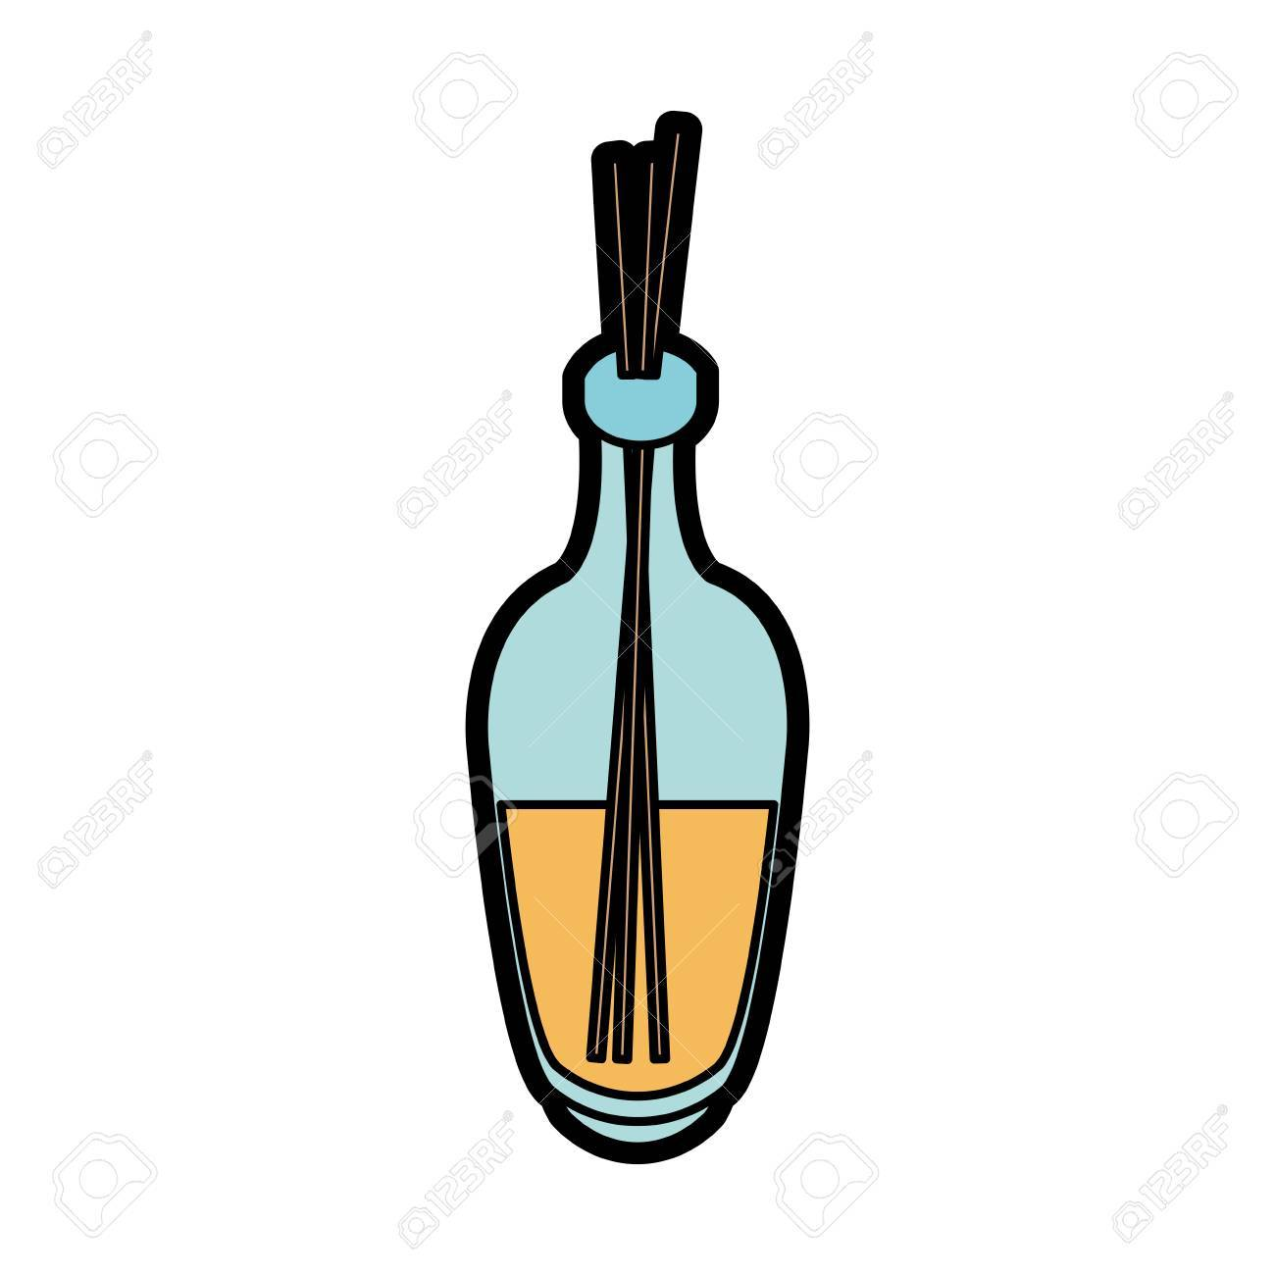

1. Explain how air freshener in a container can diffuse quickly with warmer temperature.

1. Draw a diagram using the particle model to support your answer.

(5 marks)

________________________________________________________________________________________________________________________________________________________________

________________________________________________________________________________________________________________________________________________________________

________________________________________________________________________________________________________________________________________________________________

________________________________________________________________________________________________________________________________________________________________

________________________________________________________________________________________________________________________________________________________________

________________________________________________________________________________________________________________________________________________________________

________________________________________________________________________________________________________________________________________________________________

________________________________________________________________________________________________________________________________________________________________

________________________________________________________________________________________________________________________________________________________________